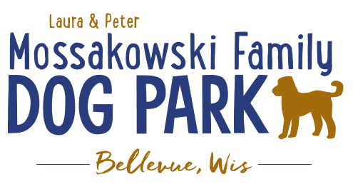
Laura and Peter Mossakowski Family Dog Park, LTD Committee Meeting

Date & Location: Wednesday, February 25th, 2026at 4:30pmat Laura Mossakowski LLC (2555 Continental Dr; Green Bay, WI 54311)

Meeting Began: 4:32pm
In attendance: Jack Le Duc, Paul Theys, Laura Mossakowski, Jennie Wertel,

VP Report:Approval of January Minutes:all in favor

Treasurer Report:Current Balance: $93,022 + $1,652.31 net village balance roughly =$94,674 total
Outstanding Bills:$238 website bill
Incoming Donations:$500 match from LPL

Secretary Report:nothing to report

Community Fundraising:

*Paul – Update on private group looking to donate with sponsorship – waiting on quote from lights-then go from there.

*Grant Writing–working on grants for solar lights & pathways
Packers Grant for 2026 is due April 1, to be eligible the work from the previous grant must be completed& it’s not. 4 years before, we can apply for this again per new Packer’s grant cycle.

*Grants and other funding needed – continue to seek DNR Grants and others, many depend on being in the Village of
Bellevue 5yr CORP. Draft sent to Village Board to include the Dog Park, that needs to be approved by the Village and then that will go on to the DNR for future eligibility for those grants over the next 5 years

Old Business:
*Kiosk needs to be leveled out when able – 2026– likely in conjunction with build out this spring/summer

*Packers Grant was secured for $3,000 (already in DP acct) & we are not eligible until this project is done,so may not be eligible again until 2030ish.

-Begin to plan what the project will look like for the lighting and ADA pathway. How many lights? How much of the park to be covered? 6-7 at least
-Lighting on pathway as well? yes
-ADA pathway estimate includes what appears to be a very large budget for restoration, is there a way that the Parks team can do that to help save the $10,000?-Yes! Could decrease the cost to $18K.
-Using Asphalt or Concrete? Kyle’s quotes were for asphalt & Mark was thinking concrete - maintenance free comparable to asphalt, but more costly than asphalt. Send Mark estimates to review per his expertise.

*Waiting for quote from Kyle on possible costs for the lighting so we can move forward.

New Business: None
Next Meeting Date: April 16, 2026 at 4:30pm @Laura Mossakowski LLC (or via zoom)
Meeting Adjourned:4:49pm

