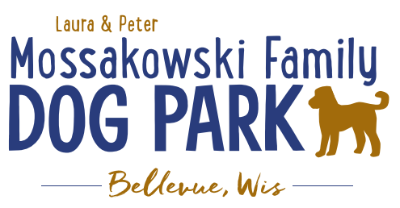
Laura and Peter Mossakowski Family Dog Park, LTD Committee Meeting

Date & Location: Thursday, April 16th, 2026 at 4:30pm at Laura Mossakowski LLC (2555 Continental Dr; Green Bay, WI 54311)

Meeting Began: 4:32pm
In attendance: Kyle Casper, Laura Mossakowski, Paul Theys, Jennie Wertel, Jac LeDuc, Shanna Alfs

VP Report: Approval of February Minutes: All Approve

Treasurer Report: Current Balance: $93,287 + $1064.05 net village balance roughly =$94,300 total
Outstanding Bills:
Incoming Donations: Grainger Donation came in

Secretary Report: No updates at this time

Community Fundraising:

*Paul – Update on private group looking to donate with sponsorship – waiting on quote from lights-then go from there.

*Grant Writing – working on grants for solar lights & pathways
Packers Grant for 2026 is due April 1, to be eligible the work from the previous grant must be completed & it’s not. 4 years before, we can apply for this again per new Packer’s grant cycle.

*Grants and other funding needed – continue to seek DNR Grants and others, many depend on being in the Village of
Bellevue 5yr CORP. Draft sent to Village Board to include the Dog Park, that needs to be approved by the Village and then that will go on to the DNR for future eligibility for those grants over the next 5 years
-Many DNR Grants on hold due to funding at the state level, none available currently

Old Business:
*Kiosk needs to be leveled out when able – 2026 – likely in conjunction with build out this spring/summer

Lighting and Pathway Project:
-Begin to plan what the project will look like for the lighting and ADA pathway. How many lights? How much of the park to be covered? 6-7 at least?
-Lighting on pathway as well? yes
-ADA pathway estimate includes what appears to be a very large budget for restoration, is there a way that the Parks team can do that to help save the $10,000?-Yes! Could decrease the cost to $18K.
-Using Asphalt or Concrete? Kyle’s quotes were for asphalt & Mark was thinking concrete - maintenance free comparable to asphalt, but more costly than asphalt. Send Mark estimates to review per his expertise.

Estimate: Lighting 4 posts ~$41,000-$49,000 depending on solar vs electric (including installation).
Benefits of electric: brighter, more reliable, and better life
Considerations for locations: at least one on the pathway, two in the large dog area, and one in the small dog area
Pathway: Looking to update estimates with concrete vs asphalt to try to see where that brings the total for the projects
Benefits of concrete: less maintenance/more durable but it costs more

New Business:
Any known water damage to report due to flooding? – unknown yet, still pending

Consider having an event that could fundraise specifically for the Lighting/Pathway project.
Look for anyone willing to plan an event for a fundraiser
Ideas: Dog walk event; Event at the park; Food Truck Rally event; Bark in the Park sort of event; Yoga in the Park; Agility or Luer Course Fun Day at the Park;
Likely need to hold the event at Josten Park or other area where there is room like we did in the past if planning a larger scale event
Plan in advance for permits and logistics, ensure that good marketing is done to draw people

Next Meeting Date: Wednesday, May 20th @9am @ Laura Mossakowski LLC (or via zoom)

Meeting Adjourned: 5:20pm

